Terraform workspace

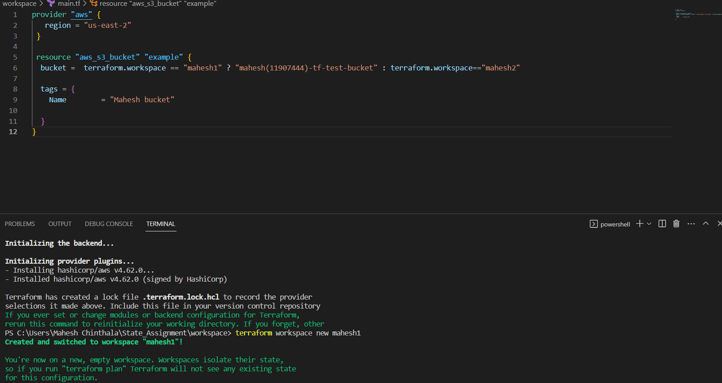

I have created terraform workspace with name mahesh1



We can see the workspace mahesh1 which I had created

